Resume by February 25, 2020

[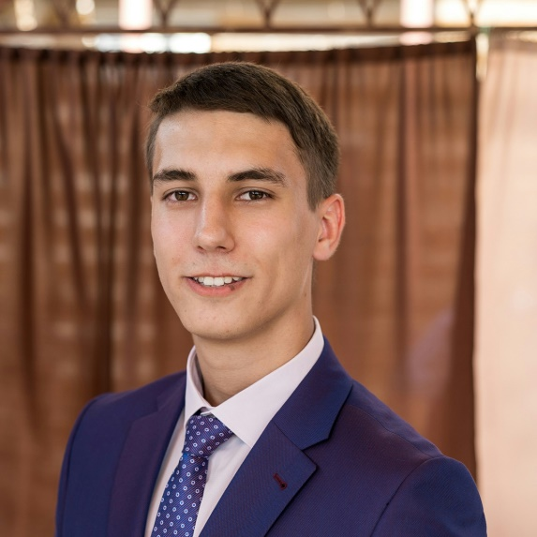](https://vk.com/id30147530)

**Tkach Maxim Sergeevich**

***Frontend-developer****, 10 000 UAH / month.*

   Full employment.

   Date of Birth: **1 april 1996** (23 years old)

   City:                **Nikolaev**

**Сontact phone number:**

1. Lifecell       +380930981357.
2. Vodafone    +380667303367.
3. Kyivstar     +380965886119.

**Education**

   NSU named after Admiral Makarov

**Machine-building, Nikolaev**

**Full higher from 09.2013 to 12.2018** (5 years 4 months)

   During my studies, I did my internship, received good reviews from the management. I finished studies with honors.

**Additional education**

* **Summer practice at the KPU. I studied a programming language STL, for composing control algorithms for mechatronic systems, namely PLC controllers. (2016, 1 week)**
* **English courses (from 2009 to 2010, 1 year)**

**Professional skills**

* **Computer skills**

Confident user of MS Office. High print speed.

**Knowledge of languages**

* **English - intermediate**
* **Russian - intermediate-advanced**
* **Ukrainian - advanced**
* **German - beginner**

**Recommendations**

* **Lugovsky O.F.**

Deputy Director of MMI, (050) 777-77-77

* **Gubarev O.P.**

School coordinator, (050) 777-77-77

* **Ganpancurova O.S.**

School coordinator, (050) 777-77-77

**Additional Information**

**I am responsible and attentive to details. I respect other people's opinions, I'm going to compromise, but at the same time I am able to defend my point of view. I work with maximum efficiency.**

**I came to this industry on the recommendation of a friend who has already been working in IT for almost 2 years. For self-development I use all the available information that is only possible to find.**

**In my free time I am engaged in self-development: reading books, watching documentaries. like to spend time playing sports: training in the gym; a game of football, basketball, table tennis and much more. I always relax in different ways, as well as actively (traveling to new places, outdoor games), and passively (watching a good movie, listening to music).**

**Social Media Links**

* [My VK profile](https://vk.com/id30147530)
* [My Instagram profile](https://www.instagram.com/marshalxmaks?r=nametag)

**Transmittal letter**

* [Letter](https://drive.google.com/open?id=1L7B79mFwmPZLQhbKk1sqEG5blpUpcLDZ)